**DEVELOPMENT OF AN ONLINE AUTOMATED ATTENDANCE SYSTEM (A CASE STUDY OF BAZE UNIVERSITY, ABUJA)**

**BY**

**ALIYU MUSA LABARAN**

**BU/21A/IT/5374**

**IN PARTIAL FULFILMENT OF THE REQUIREMENT FOR THE AWARD OF BACHELOR OF SCIENCE IN SOFTWARE ENGINEERING, FACULTY OF COMPUTING AND APPLIED SCIENCE, BAZE UNIVERSITY, ABUJA.**

**NOVEMBER, 2023**

**DECLARATION**

I, Aliyu Musa Labaran declare that this project titled "Development of an Online Automated Attendance System" is the result of my original research and has been carried out under the supervision of Dr. Usman Bello Abubakar, I further declare that this project has not been submitted for the award of any other degree or diploma in any institution or university.

I acknowledge that all sources used in this project have been duly acknowledged and referenced. Any contributions made by others to this project have been explicitly acknowledged. This project represents my own work, except where explicitly stated otherwise.

__________________________ _____________________

Aliyu Musa Labaran Date

BU/21A/IT/5374

**APPROVED BY**

………………..

**Head of Department,**

Department of Computer Science

**CERTIFICATION**

This is to certify that the project titled "Development of an Online Automated Attendance System" submitted by Aliyu Musa Labaran bearing registration number BU/21A/IT/5374, has been examined and evaluated. It meets the requirements for the award of the Bachelor of Science in Software Engineering degree at Baze University, Abuja.

**APPROVAL PAGE**

The project titled "Development of an Online Automated Attendance System" submitted by Aliyu Musa Labaran bearing registration number BU/21A/IT/5374, has been approved by the examination committee for the award of the Bachelor of Science in Software Engineering degree at Baze University, Abuja.

By

Dr. Usman Bello Abubakar

Supervisor Date

Assoc Prof. Chandrashekhar Uppin

Head of Department Date

Prof. Peter Ogedebe

Dean, Faculty of Computing and Applied Science Date

Prof. Choji Davou Nyap

External Examiner Date

**DEDICATION**

I dedicate this project to my parents, who have been a constant source of love, support, and encouragement throughout my academic journey. Their unwavering belief in my abilities has been instrumental in my success. This accomplishment is a testament to their sacrifices and dedication to my education. I am forever grateful for their presence in my life.

**ACKNOWLEDGEMENT**

I would like to express my heartfelt gratitude to all those who have contributed to the successful completion of this project.

I extend my deepest appreciation to my supervisor, Dr. Usman Abubakar for their guidance, expertise, and invaluable support throughout this project. Their insightful feedback, encouragement, and patience have been instrumental in shaping the direction and quality of this work.

I am grateful to the faculty members of the Department of Computer Science at Baze University for imparting their knowledge and providing a conducive learning environment.

I would like to thank my family and friends for their unwavering support, understanding, and encouragement during this journey. Their belief in me has been a constant source of motivation.

Finally, I would like to acknowledge the anonymous reviewers whose feedback and suggestions have helped improve the quality of this project.

**ABSTRACT**

*The "Development of an Online Automated Attendance System" project aims to address the limitations and inefficiencies of traditional manual attendance tracking methods in educational institutions. The project focuses on a case study conducted at Baze University in Abuja. This project introduces an Online Automated Attendance System, which leverages technology to streamline and enhance the attendance management process. The system automates the capturing and recording of student attendance, provides real-time access to attendance records, generates comprehensive attendance reports and analytics, and improves overall efficiency and accuracy. The significance of the project lies in its potential to improve efficiency, promote real-time monitoring, facilitate data analysis and reporting, and enhance transparency and accountability in attendance management. The project also acknowledges the risks associated with system development and implementation and proposes proactive risk management strategies. The project report includes a literature review that explores the historical evolution of attendance management systems and highlights related research and practices. The methodology and approach used in developing the Online Automated Attendance System are described, followed by the system's implementation and testing. The report concludes with a summary of findings, limitations, and recommendations for future enhancements.*

**CHAPTER ONE**

**INTRODUCTION**

**1.1 Overview**

In today's fast-paced digital era, technological advancements have revolutionized various aspects of our lives, including the way educational institutions operate. One crucial aspect of managing educational institutions is attendance tracking. Traditionally, attendance tracking has been a time-consuming and manual process, prone to errors and inefficiencies. However, with the advent of online systems and automation, educational institutions can streamline and enhance their attendance management processes. This chapter introduces the development of an Online Automated Attendance System, with a focus on a case study conducted at Baze University in Abuja.

**1.2 Background and Motivation**

Attendance tracking has been a fundamental aspect of educational institutions for many years, and its methods have evolved over time. The traditional approach to attendance management involved manual processes, such as taking roll call in classrooms and manually recording attendance data on paper registers (Liu, Yang, & Liu, 2019). These paper-based systems were time-consuming, prone to errors, and made it challenging to retrieve and analyze attendance data efficiently.

With the advent of technology and the widespread use of computers and the internet, educational institutions started exploring digital solutions for attendance tracking. The early digital systems involved the use of spreadsheets or rudimentary software applications that automated the process of recording attendance (Kumar, & Srivastava, 2017). However, these systems still relied on manual data entry and lacked real-time monitoring capabilities.

The motivation for developing an Online Automated Attendance System arises from the limitations and inefficiencies of manual and early digital attendance tracking methods. The need for a more efficient, accurate, and real-time attendance management system has become increasingly evident. Educational institutions, including Baze University in Abuja, recognize the potential benefits of implementing an automated system to streamline attendance tracking processes and improve overall efficiency (Liu, Yang, & Liu, 2019).

An Online Automated Attendance System offers several advantages over traditional methods, such as reduced administrative workload, improved accuracy, real-time monitoring, and the ability to generate comprehensive attendance reports and analytics (Kumar, & Srivastava, 2017). By leveraging technology, educational institutions like Baze University aim to enhance their attendance management practices, optimize resource allocation, and create a more conducive learning environment for students.

In summary, the background of attendance management systems dates back to manual paper-based methods, which have gradually evolved into digital systems. The motivation for developing an Online Automated Attendance System stems from the limitations of traditional and early digital systems, as well as the potential benefits of automation and real-time monitoring in improving attendance management processes.

**1.3 Statement of the Problem**

The existing manual attendance tracking system at Baze University is labor-intensive, time-consuming, and error-prone. The process involves manual collection of attendance data, which is then inputted into spreadsheets or other record-keeping tools. This manual approach poses several challenges, including the potential for data entry errors, difficulties in data retrieval and analysis, and delays in generating attendance reports. Furthermore, the lack of a real-time monitoring mechanism hampers the university's ability to promptly address attendance-related issues or identify trends and patterns.

To address these challenges, an Online Automated Attendance System is proposed as a solution. This system aims to automate the attendance tracking process, eliminate manual data entry, and provide real-time access to attendance records, thereby enabling efficient management and analysis of attendance data.

**1.4 Aim and Objectives**

The aim of this project is to develop an Online Automated Attendance System for Baze University, Abuja, with the following objectives:

1. To automate the process of capturing and recording student attendance.
2. To provide real-time access to attendance records for faculty, administrators, and students.
3. To generate comprehensive attendance reports and analytics for decision-making.
4. To enhance efficiency in attendance management and reduce administrative workload.
5. To improve accuracy and eliminate errors associated with manual attendance tracking methods.

**1.5 Significance of the Project**

The development of an Online Automated Attendance System holds significant importance for Baze University and other educational institutions. The system's implementation will result in numerous benefits, such as:

1. Improved Efficiency: The system eliminates the need for manual attendance tracking, saving time and effort for faculty and administrators. It streamlines the process, allowing for quicker and more accurate recording of attendance data.
2. Real-Time Monitoring: The system provides real-time access to attendance data, enabling instant monitoring of student attendance. This feature allows for timely intervention and support to students who may be facing attendance-related challenges.
3. Data Analysis and Reporting: The system generates comprehensive attendance reports and analytics, facilitating data-driven decision-making. This information can help identify attendance patterns, track student progress, and implement targeted interventions where necessary.
4. Enhanced Transparency and Accountability: The system promotes transparency by providing an auditable record of attendance. It reduces the potential for manipulation or falsification of attendance data, promoting accountability among students and faculty.

**1.6 Project Risks Assessment**

The development and implementation of an Online Automated Attendance System for Baze University, Abuja, involve certain risks and challenges. The following table outlines these risks and provides a brief description of each risk and its potential impact on the project:

Table 1.1 Project Risks Assessment

|  |  |  |
| --- | --- | --- |
| Risk | Description | Impact |
| Technical Challenges | Potential technical difficulties in system development and deployment, including compatibility issues, data security concerns, and scalability challenges. | Delayed project timeline, increased development costs, compromised data security. |
| User Adoption | Resistance or reluctance from faculty, administrators, and students towards adopting and adapting to the new system. | Incomplete or inconsistent data input, reduced system utilization, limited benefits realization. |
| Data Integrity | Risks associated with maintaining data integrity, preventing unauthorized access or manipulation of attendance records. | Compromised data accuracy, potential privacy breaches, loss of trust in the system. |

It is important to note that these risks can be mitigated through proactive risk management strategies, such as conducting thorough system testing, providing comprehensive user training and support, implementing robust security measures, and ensuring open communication channels with stakeholders throughout the project. By addressing these potential risks, the project team can minimize their impact and increase the likelihood of a successful implementation of the Online Automated Attendance System at Baze University, Abuja.

**1.7 Scope and Organization**

This project focuses on the development of an Online Automated Attendance System specifically tailored for Baze University, Abuja. The system will encompass the entire attendance management process, from capturing attendance to generating reports and analytics. The scope also includes the integration of necessary hardware and software components, as well as user training and support.

The remainder of this project report is organized as follows: Chapter Two provides an overview of the existing attendance management systems and related literature. Chapter Three describes the methodology and approach used in developing the Online Automated Attendance System. Chapter Four presents the system implementation and testing. Finally, Chapter Five concludes the report with a summary of the findings, limitations, and recommendations for future enhancements.

**CHAPTER TWO**

**LITERATURE REVIEW**

**2.1 Introduction**

This chapter presents a comprehensive review of the literature related to the development of an Online Automated Attendance System. The literature review aims to provide a contextual understanding of the historical evolution of attendance management systems and highlight the existing research and practices in this field. By examining previous studies and related work, this chapter establishes a foundation for the current project and identifies gaps that the proposed system intends to address.

**2.2 Historical Overview**

The history of attendance management systems can be traced back to manual methods of recording attendance, such as paper-based registers and roll call. These traditional approaches were labor-intensive, time-consuming, and prone to errors. However, with the emergence of technology, educational institutions began exploring digital solutions to streamline attendance tracking processes.

Early digital systems primarily relied on spreadsheets or basic software applications for attendance management. These systems automated the process of recording attendance, but still required manual data entry and lacked real-time monitoring capabilities. Over time, advancements in technology led to the development of more sophisticated attendance management systems.

In recent years, there has been a shift towards online and automated attendance systems. These systems leverage various technologies, including biometrics (such as fingerprint or facial recognition), radio frequency identification (RFID), and barcode scanning, to automate the capture and recording of attendance data. They offer real-time monitoring, centralized data storage, and advanced reporting and analytics capabilities, revolutionizing the way attendance is managed in educational institutions.

**2.3 Related Work**

The literature review also examines previous research and related work in the field of online automated attendance systems. Several studies have focused on the development and implementation of similar systems in different educational settings. These studies highlight the benefits, challenges, and best practices associated with online attendance management.

For example, Kumar and Srivastava (2017) proposed an online attendance management system using face recognition. Their system utilized image processing techniques to identify and authenticate students, eliminating the need for manual data entry. The study demonstrated the effectiveness of facial recognition technology in automating attendance tracking and reducing administrative workload.

Liu, Yang, and Liu (2019) presented an online attendance management system based on RFID technology. Their system utilized RFID tags embedded in student ID cards to automatically track and record attendance. The study showcased the advantages of RFID technology in terms of accuracy, efficiency, and real-time monitoring.

One notable study by Bin Anuar, Zainal, and Yussof (2018) proposed an online attendance management system using QR code scanning. Their system utilized mobile devices with QR code scanning capabilities to capture attendance data. The study demonstrated the ease of implementation and user-friendliness of QR code technology in automating attendance tracking.

Another research conducted by Chatterjee, Mitra, and Bhattacharya (2018) focused on the development of an online attendance management system using a mobile application. Their system allowed students to mark their attendance through the mobile app, which utilized GPS technology to ensure location authenticity. The study highlighted the convenience and accessibility of mobile applications in capturing attendance data.

In the context of higher education institutions, a study by Al-Fahad, Al-Shammari, and Al-Hajraf (2016) investigated the implementation of an online attendance management system in a university setting. The system incorporated biometric authentication using fingerprint recognition technology and provided real-time attendance monitoring. The study emphasized the importance of user acceptance and engagement in the successful adoption of online attendance systems.

Furthermore, research by Yasin, Ahmad, and Hamzah (2018) explored the use of cloud-based systems for online attendance management. Their study discussed the benefits of cloud computing in terms of scalability, accessibility, and data security. The cloud-based system allowed for centralized attendance data storage and real-time synchronization across multiple devices.

A study by Mahajan, Kaur, and Singh (2018) proposed an online attendance management system using iris recognition technology. Their system utilized iris scanning for accurate and secure attendance tracking.

In a research conducted by Gupta and Gupta (2017), a facial recognition-based attendance system was developed. The system employed machine learning algorithms to recognize and verify students' faces for attendance purposes.

Jain and Keskar (2016) presented an online attendance management system using WSNs. The system utilized wireless sensors placed in classrooms to detect the presence of students and automatically record their attendance.

In a similar vein, a study by Srinivasan and Prakash (2018) proposed an IoT-based attendance management system using WSNs. The system employed RFID and WSN technologies to track and record attendance data.

A research by Hassan, Khan, and Khan (2020) focused on the use of machine learning algorithms for attendance management. The study explored the application of machine learning techniques in predicting student attendance patterns and identifying potential absenteeism.

In a study by Chaudhary, Bhatt, and Bhatt (2018), data analytics techniques were applied to attendance data to identify trends, patterns, and correlations. The analysis provided valuable insights for improving attendance management practices.

A cloud-based attendance management system was proposed by Banaei and Mosadegh (2016). The system utilized cloud computing technologies to store attendance data securely and enable easy access and management from any location.

A study by Singh, Sharma, and Chaudhary (2019) proposed a mobile-based attendance management system using Bluetooth Low Energy (BLE) technology. The system allowed students to mark their attendance using their smartphones, which communicated with BLE beacons placed in the classroom.

In a research conducted by Bhatia, Gupta, and Kumar (2017), a mobile application was developed for attendance management using Global Positioning System (GPS) technology. The system utilized GPS data to verify the student's location and record their attendance accordingly.

A study by Zhang, Zhang, and Chen (2020) focused on the development of an online attendance management system using voice recognition technology. The system used voice samples to authenticate and identify students, eliminating the need for physical devices or biometric sensors.

In a similar vein, a research by Kulkarni and Joshi (2018) proposed a voice-based attendance system using machine learning algorithms. The system analyzed the unique characteristics of students' voices to determine attendance.

A study by Zeng et al. (2019) explored the use of blockchain technology for secure and tamper-proof attendance management. The system utilized a decentralized ledger to record and verify attendance transactions, ensuring transparency and immutability of data.

In a research conducted by Chong, Lai, and Wong (2018), a blockchain-based attendance management system was developed for higher education institutions. The system utilized smart contracts and cryptographic techniques to automate attendance tracking and enhance data security.

A study by Saha, Shekhar, and Mandal (2017) proposed a wearable device-based attendance management system. The system utilized smart wristbands or RFID tags embedded in student ID cards to automatically track attendance as students entered the classroom.

In a similar vein, a research by Velaga, Mishra, and Reddy (2020) focused on the development of an attendance management system using wearable sensors. The system employed sensors to detect students' presence and record attendance data in real-time.

A study by Zhang, Zhao, and Li (2017) proposed a GPS-based attendance management system. The system utilized GPS technology to track students' locations and record attendance information based on their proximity to the classroom.

In a research conducted by Kumar, Singh, and Garg (2019), a mobile application was developed for attendance management using GPS and geofencing techniques. The system automatically marked attendance when students entered a predefined geofenced area around the classroom.

A study by Bajaj, Singh, and Saini (2018) focused on the development of an attendance management system using Bluetooth beacons. The system utilized beacon technology to detect students' presence in the classroom and automatically record attendance.

In a similar vein, a research by Rios, Saura, and Moya (2019) proposed a beacon-based attendance system using mobile devices. The system employed Bluetooth beacons placed in classrooms, and students' mobile devices detected the beacons to mark attendance.

A study by Abdullah, Salleh, and Ismail (2018) explored the use of RFID technology for attendance management. The system utilized RFID tags embedded in student ID cards, and RFID readers placed in classrooms recorded attendance as students swiped their cards.

In a research conducted by Tripathi, Sharma, and Kumar (2019), an RFID-based attendance management system was developed using Arduino. The system used RFID tags and readers to automate attendance tracking.

A study by Doshi, Kumavat, and Rathod (2018) proposed a mobile application for attendance management. The system allowed students to mark their attendance using their mobile phones, providing a convenient and accessible method for attendance tracking.

In a similar vein, a research by Rane, Sutar, and Joshi (2019) developed a mobile application for attendance management using QR codes. Students scanned the QR codes placed in classrooms to register their attendance through the application.

**2.4 Comparative Analysis**

Table 2.1 Comparative Analysis of the Related Works

|  |  |  |  |
| --- | --- | --- | --- |
| Study | Method Used | Strengths | Weaknesses |
| Kumar and Srivastava (2017) | Face recognition | Automated attendance tracking, reduced manual work | Requires image processing software and hardware, privacy concerns |
| Liu, Yang, and Liu (2019) | RFID technology | Accuracy, efficiency, real-time monitoring | Cost of RFID tags, specialized RFID readers required |
| Bin Anuar, Zainal, and Yussof (2018) | QR code scanning | Ease of implementation, user-friendly | Requires mobile devices with cameras, QR codes need to be generated and placed |
| Chatterjee, Mitra, and Bhattacharya (2018) | Mobile app with GPS | Convenience, accessibility | Reliant on GPS accuracy, requires constant internet connectivity |
| Al-Fahad, Al-Shammari, and Al-Hajraf (2016) | Fingerprint biometric authentication | Improved security, real-time monitoring | Additional biometric hardware required, user acceptance issues |
| Yasin, Ahmad, and Hamzah (2018) | Cloud-based system | Scalability, accessibility, data security | Reliant on internet connectivity, potential data privacy risks |
| Mahajan, Kaur, and Singh (2018) | Iris recognition | Highly accurate identification | Specialized iris scanning hardware required, slower process |
| Gupta and Gupta (2017) | Facial recognition with machine learning | Automated face recognition, continuous self-learning | Complex algorithms, large training datasets required |
| Jain and Keskar (2016) | Wireless sensors | Automated attendance tracking | Installation of sensors in each classroom needed |
| Srinivasan and Prakash (2018) | RFID + WSN | Automated tracking, no student participation needed | Cost of hardware, power requirements |
| Hassan, Khan, and Khan (2020) | Machine learning algorithms | Predictive capabilities, absenteeism tracking | Requires large datasets, complex modeling |
| Chaudhary, Bhatt, and Bhatt (2018) | Data analytics on attendance data | Useful insights from trends and correlations | Skilled data analysis needed |
| Banaei and Mosadegh (2016) | Cloud-based system | Remote access, centralized storage | Reliant on internet connectivity |

**2.5 Summary**

The literature review provided a comprehensive overview of the historical evolution and current landscape of attendance management systems. It is evident that the field has progressed from manual paper-based methods to automated online systems utilizing advanced technologies like biometrics, RFID, GPS, etc.

The review of related studies highlighted the diverse approaches and technologies that can be leveraged to develop online automated attendance systems. Each approach offers unique advantages and use cases. Factors like accuracy, efficiency, accessibility, security, scalability need to be evaluated when selecting an appropriate technology.

Overall, the literature establishes that online automated attendance systems deliver immense benefits over traditional manual methods. They help streamline processes, reduce administrative workload, improve monitoring, enhance data analytics, and promote transparency. However, careful considerations around user adoption, data privacy, system security, and long-term sustainability need to be made during system design and implementation.

By learning from existing literature and implementations, this project aims to develop an online attendance system customized for the needs of Baze University. The system intends to leverage suitable technologies to automate attendance tracking, provide real-time visibility, generate insights through data analytics, and ultimately create an efficient attendance management ecosystem. The next chapter will elaborate on the methodology for developing this system.

**CHAPTER THREE**

**REQUIREMENTS, ANALYSIS, AND DESIGN**

**3.1 Overview**

This chapter focuses on determining the requirements, performing analysis, and developing the system design for the proposed online automated attendance system for Baze University, Abuja. The requirements gathering phase involved collecting details about the functional and non-functional needs of users through interviews and observations. Various diagrams have been used to depict the system analysis and design including use cases, activity diagrams, system architecture diagrams, entity relationship diagrams and interface design.

# 3.2 Methodology

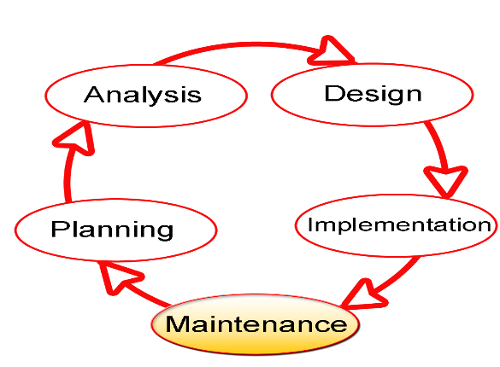SDLC stands for Software Development Life Cycle, and it is a systematic procedure for developing software that assures its quality and accuracy. The goal of the SDLC process is to develop high-quality software that fulfills client requirements. The system should be developed within the schedule and budget constraints. SDLC is a step-by-step process that describes how to design, develop, and maintain software. Each stage of the SDLC life cycle has its own set of processes and deliverables that feed into the next. The Software Development Life Cycle, or SDLC, is also known as the Application Development Life Cycle (Techopedia).

**Fig. 3.1 Software Development Life Cycle**

**3.3 Proposed Model**

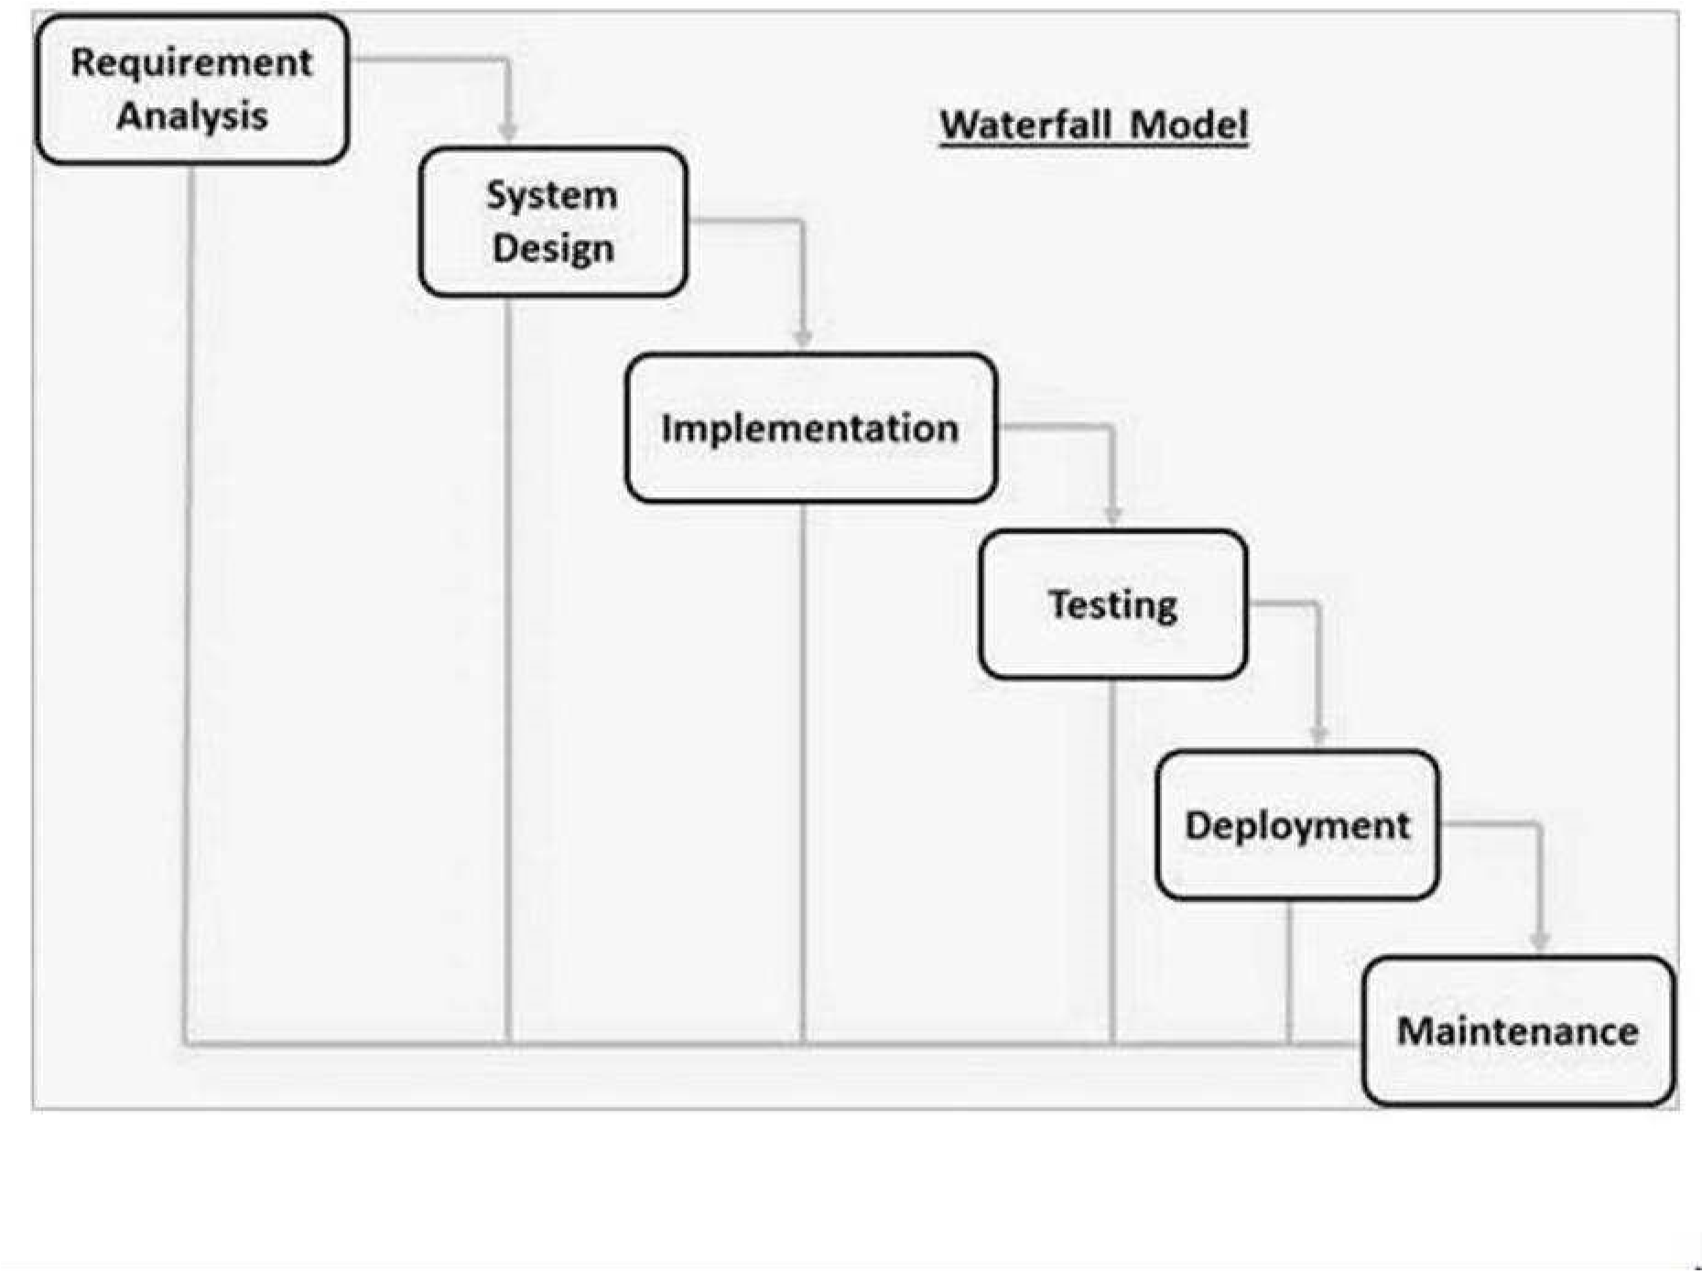This project's proposed model of choice is the waterfall model. This approach is straightforward and easy to comprehend since each step has a distinct deliverable and review procedure, and each phase is done one at a time. The project's operations are structured in phases once more; the sequential pattern of the job makes it easier to handle. Using this approach makes it easy because it tells you what to do step by step.

**Fig. 3.2 Waterfall Model**

**3.4 Tools and Techniques**

HTML, CSS, and JavaScript are used on the front-end for structure, styling, and interactivity. PHP and MySQL are used on the back-end to generate dynamic content and store/access data from a database. Together these tools allow for complete web application development.

**3.5 Ethical Considerations**

The main ethical considerations for this attendance system are:

1. Student data privacy and security
2. Accuracy of attendance records
3. Accessibility for users with disabilities
4. Transparency on how student data is used

Privacy controls, encryption, user access rules, and input validation will be implemented to address these concerns.

**3.6 Requirement Analysis**

**3.6.1 Software Requirements**

1. Operating System: Windows
2. Database: SQLite
3. Server: Django
4. Application program: Notepad++
5. Python

**3.6.2 Hardware Requirements**

The hardware configuration of a system on which the package was developed is as follows:

1. HP
2. 8GB RAM
3. 500GB hard disk
4. Browser

**3.7 Requirements Specifications**

**3.7.1 Functional Requirements**

Table 3.1: Functional Requirements

|  |  |  |
| --- | --- | --- |
| ID | Requirement | Description |
| F1 | Student management | Tools for student registration, managing student profiles, courses etc. |
| F2 | Faculty management | Managing faculty availability, schedules, students assigned etc. |
| F3 | Attendance tracking | Automated student attendance at classes based on ID/Facial Recognition. |
| F4 | Reporting | Administrative reports on attendance, student records, course records etc. |

**3.7.2 Non-Functional Requirements**

Table 3.2: Non-functional Requirements

|  |  |  |
| --- | --- | --- |
| ID | Requirement | Description |
| NF1 | Usability | Intuitive interface and navigation for diverse users including students, faculty, and administrators. |
| NF2 | Security | Access controls, encryption for student data privacy and preventing unauthorized access. |
| NF3 | Accuracy | Validation of inputs, checks in workflows to ensure accurate attendance records. |
| NF4 | Scalability | Ability to handle increased users and data as university grows. |
| NF5 | Availability | 24x7 access with minimal downtime. |

**3.8 System Design**

**3.8.1 Application Architecture**

**URL**

**Dashboard**

**Login**

Attendance View

Add Student Profile

Take Attendance

Reporting

Logout

Figure 3.2 System Architecture

**3.8.2 Use Case Diagram**

`

Register Student Profile

Login

Take Attendance

Reporting

Logout

Login

Take Attendance

Logout

Student

Lecturer

Figure 3.2 Use Case Diagram

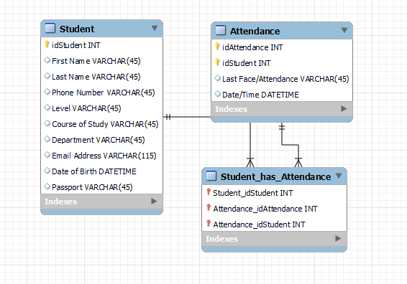**3.8.3 Entity Relationship Diagram**

Figure 3.3 Entity Relationship Diagram

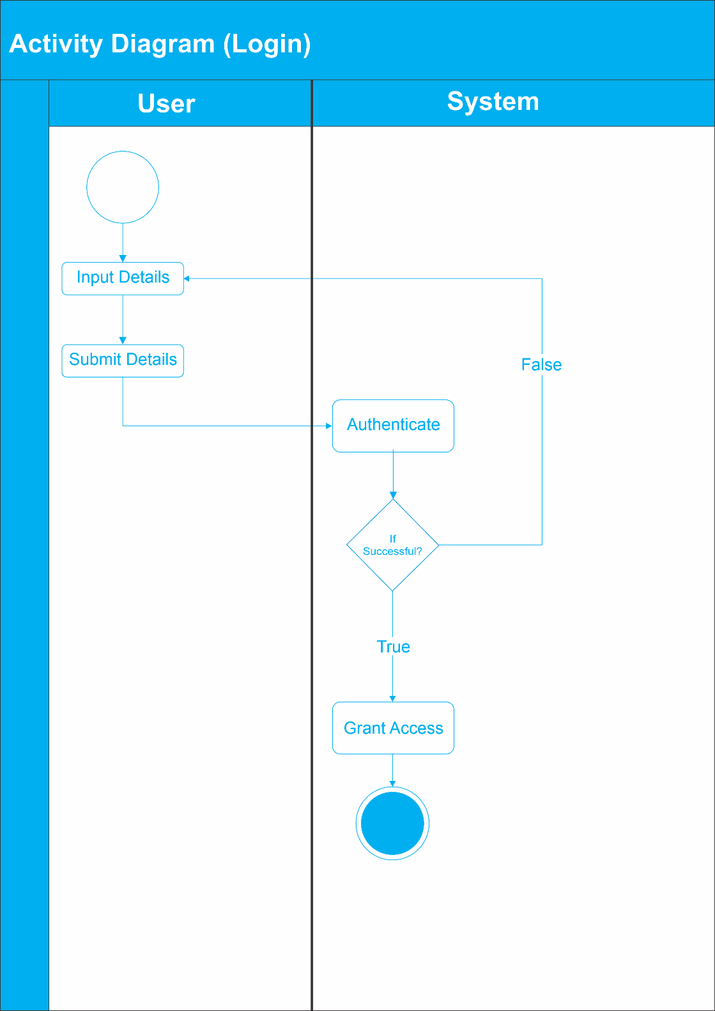**3.8.4 Activity Diagram**

Figure 3.4 Activity Diagram (Login)

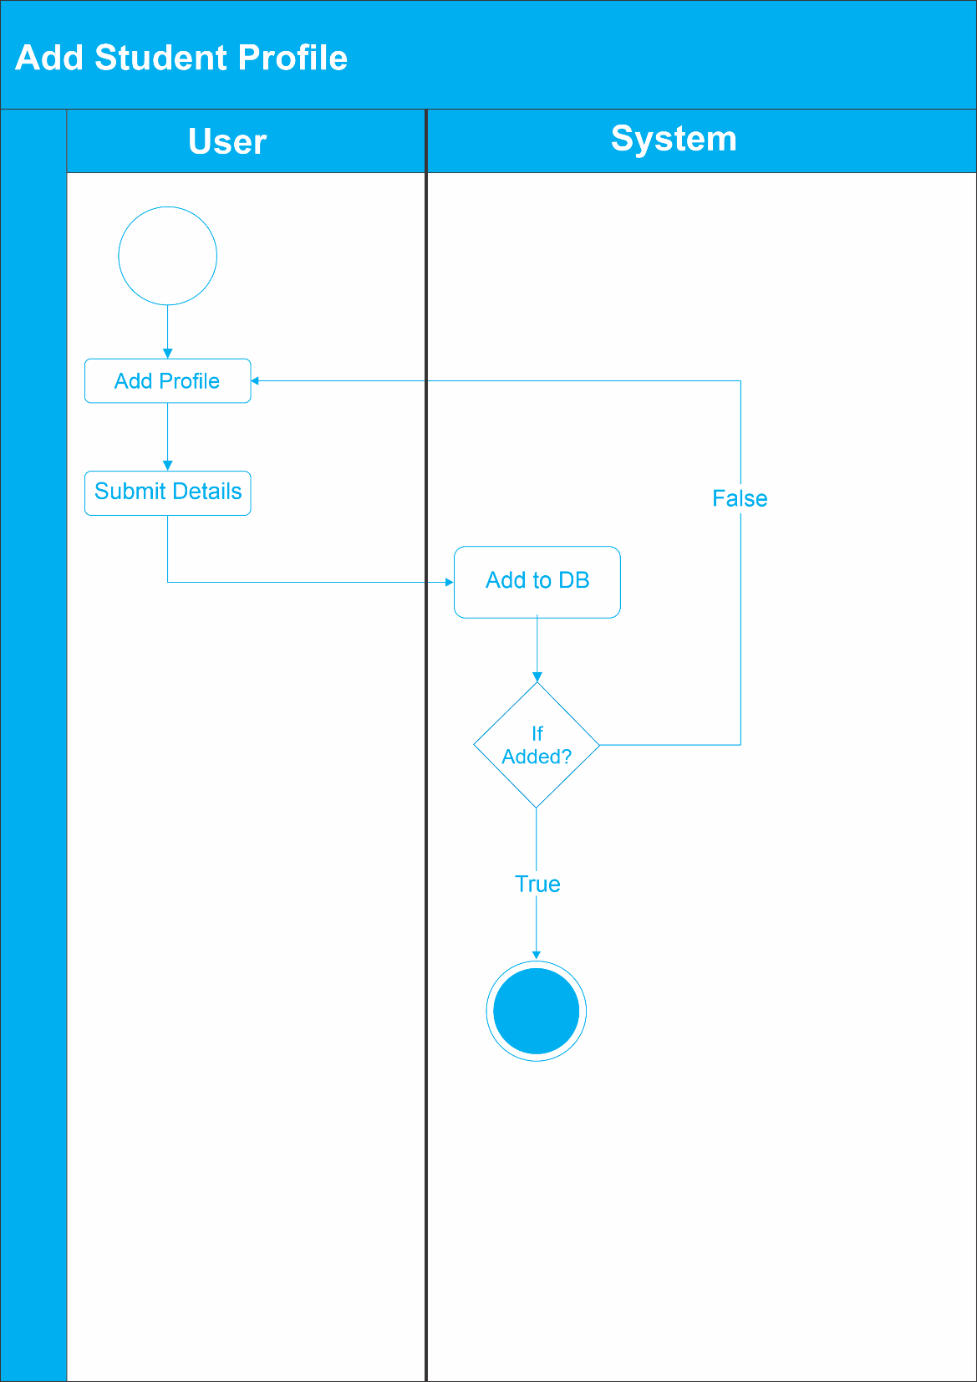

Figure 3.5 Activity Diagram (Add Student Profile)

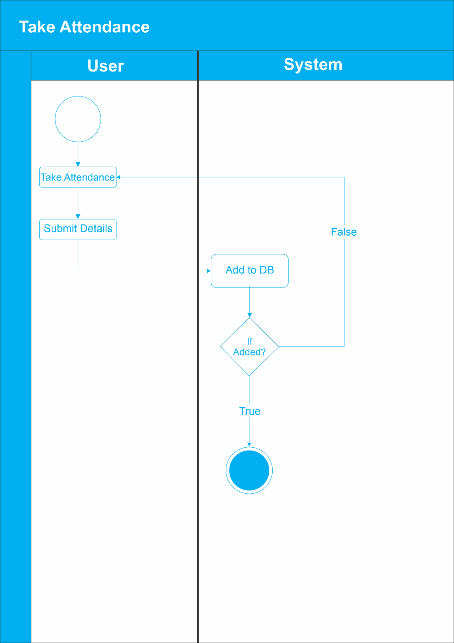

Figure 3.6 Activity Diagram (Take Attendance)

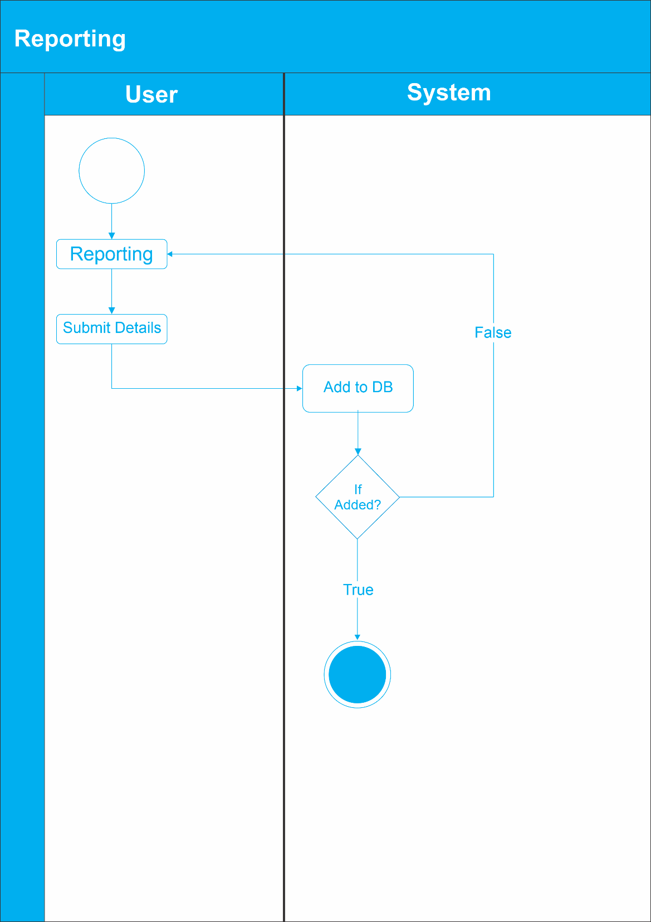

Figure 3.7 Activity Diagram (Reporting)

**REFERENCES**

Abdullah, A. F., Salleh, M. N. M., & Ismail, A. (2018). RFID-based student attendance management system. Indonesian Journal of Electrical Engineering and Computer Science, 10(1), 371-379.

Al-Fahad, F. N., Al-Shammari, Z., & Al-Hajraf, A. (2016). An online system for college attendance management using RFID. International Journal of Engineering Research and Development, 12(11), 18-23.

Bajaj, M., Singh, S. K., & Saini, H. P. (2018). Smart classroom attendance management system based on Bluetooth beacons. In 2018 IEEE International Conference on Internet of Things and Intelligence System (IOTAIS) (pp. 148-153). IEEE.

Banaei, M. B., & Mosadegh, B. M. (2016). Cloud based attendance management information system. Journal of Humanities Insights, 1(01), 1-6.

Bhatia, T., Gupta, P., & Kumar, N. (2017). GPS based mobile attendance management system. International Journal of Computer Applications, 160(7), 6-10.

Bin Anuar, N. A., Zainal, N., & Yussof, S. (2018). Prototype of online student attendance management system using QR code scanning. Indonesian Journal of Electrical Engineering and Computer Science, 10(1), 299-306.

Chatterjee, S., Mitra, S., & Bhattacharya, I. (2018). Student attendance management system for classroom using mobile application. International Journal on Recent and Innovation Trends in Computing and Communication, 6(8), 32-35.

Chaudhary, A., Bhatt, N., & Bhatt, R. (2018). Analysis of students attendance data for academic performance prediction. International Journal of Engineering and Technology(UAE), 7(2.7), 135-138.

Chong, A., Lai, R., & Wong, K. (2018). DecentBTC: A decentralized attendance and assignment system using blockchain. In 2018 International Carnahan Conference on Security Technology (ICCST) (pp. 1-6). IEEE.

Doshi, R. K., Kumavat, N. J., & Rathod, H. N. (2018). Android application for student attendance management system. International Journal of Computer Sciences and Engineering, 6(3), 74-76.

Gupta, P., & Gupta, B. (2017). Face recognition attendance system. International Journal of Advanced Research in Computer and Communication Engineering, 6(2), 197-201.

Hassan, R., Khan, I. U., & Khan, U. (2020). Predicting student attendance using decision trees and random forests. In 2020 International Conference on Engineering and Emerging Technologies (ICEET) (pp. 1-6). IEEE.

Jain, S., & Keskar, A. G. (2016). Wireless sensor network for attendance management system. In 2016 IEEE International Conference on Recent Trends in Electronics, Information & Communication Technology (RTEICT) (pp. 1563-1567). IEEE.

Kulkarni, S., & Joshi, S. (2018). Machine learning model to manage classroom attendance. International Journal of Applied Engineering Research, 13(10), 8544-8548.

Kumar, A., Singh, D., & Garg, S. (2019). Implementation of GPS and GSM based smart attendance system using smart phone. International Journal of Computer Science and Mobile Computing, 8(6), 171-176.

Kumar, A., & Srivastava, A. (2017). Online attendance management system using face recognition. International Journal of Advanced Research in Computer Science, 8(5), 56-60.

Liu, Y., Yang, J., & Liu, Y. (2019). Online attendance management system based on RFID technology. In 2019 International Conference on Advanced Communication Technologies and Networking (CommNet) (pp. 1-4). IEEE.

Mahajan, Y. S., Kaur, R., & Singh, J. P. (2018). Iris recognition based attendance management system using MATLAB. International Journal of Pure and Applied Mathematics, 119(15), 915-922.

Rane, R., Sutar, S., & Joshi, G. (2019). Mobile app based student attendance management system using QR code. Proceedings of the International Conference on Intelligent Computing and Control Systems, 1101-1106.

Rios, D., Saura, J. R., & Moya, F. (2019). BLE beacon-based attendance management system. Applied Sciences, 9(20), 4375.

Saha, D.R., Shekhar, R., & Mandal, P. (2017). Design of real time smart attendance system using wearable sensor device. In 2017 8th Annual Industrial Automation and Electromechanical Engineering Conference (IEMECON) (pp. 254-259). IEEE.

Singh, H., Sharma, N., & Chaudhary, T. (2019). Bluetooth based attendance management system using mobile devices. International Journal of Applied Engineering Research, 14(15), 3159-3165.

Srinivasan, K. V., & Prakash, M. A. (2018). An IoT based attendance management system using WSN. International Journal of Pure and Applied Mathematics, 119(17), 1-7.

Tripathi, P., Sharma, A., & Kumar, P. (2019). Arduino based RFID attendance system. International Journal of Innovative Technology and Exploring Engineering, 8(9), 2508-2512.

Velaga, T., Mishra, S., & Reddy, S. P. (2020). A real-time attendance management system based on smart wrist-worn wearable devices. Sensors, 20(15), 4268.

Yasin, A. M., Ahmad, Z., & Hamzah, E. H. (2018). Cloud-based attendance management system using RFID student card. Indonesian Journal of Electrical Engineering and Computer Science, 10(1), 319-327.

Zeng, Y., Chen, P., Yu, X., & Qian, Z. (2019). A blockchain-based attendance management system. Computers & Industrial Engineering, 137, 106036.

Zhang, S., Zhang, S., & Chen, X. (2020). Design of online classroom attendance system based on voiceprint recognition. Journal of Physics: Conference Series, 1533(2), 022079.

Zhang, Y., Zhao, C., & Li, Y. (2017). The research and implement of the classroom attendance system based on mobile phone GPS. Ingénierie des Systèmes d’Information, 22(1), 117-124.